Cloud Computing

(B9IS108)

Module/Subject Title: Business Strategy.

Lecturer Name: Paul Laird.

Assignment Title: CA-2 Group Assignment.

Student Name & Number:

Bhushan Chaudhari (10517074)

Pavan Pardeshi (10380700)

Table of Contents

Introduction 3

Pages 3

Login 3

Notes 4

Upgrade 5

Query 5

Team 6

Applications and software used 6

Microsoft azure 7

GitHub 7

Sublime text2/Notepad++ 8

Database & Languages 9

Conclusion 10

# Introduction

As proposed, we are delivering the web application for submitting, creating and editing notes on a website which is developed for the educational system known as “WHITEBOARD”.

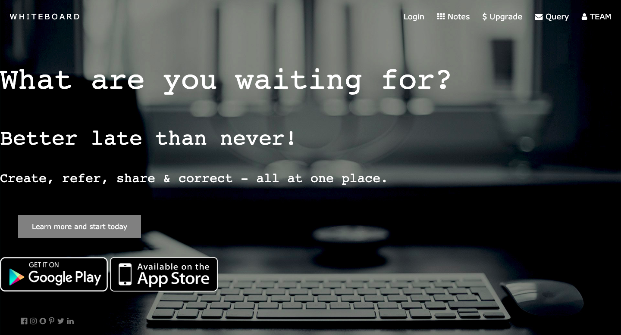

# As shown in the above image, the home page is linked with 5 major pages which have unique features and each page i.e. the entire website is linked with each other. The five pages are login, notes, upgrade, query and team. This project aims to deliver an HTML, CSS, JavaScript, and Python-based web application with the help of MySQL server to help students upload their notes. Students can verify the notes from experts and they can use the services provided by whiteboards such as storage, email service and support from experts.

# Pages

Will see each page and their features and workings one by one below;

## Login

As per the proposed idea, this web application is for creating notes online and sharing those with expert teachers as well as other users. Students can log in to the portal by using the sign-in button which is the integration of google sign in. This google sign-in is only used for the authentication of the user. If the user is not yet registered, then he or she must file the form given so that to update the personal information into the database. If the information in the database is the same as the Google sign-in account, then the access will be granted to the user to use further benefits from the web app.

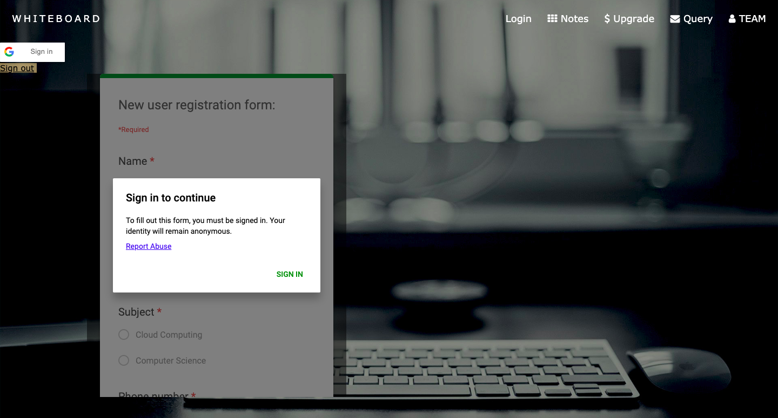

## Notes

Notes are an important section of this web app. This is because the user can create files related to the particular subject and add it to the database by clicking on the submit button. On the other hand, one can also upload files by choosing from their system storage. Everyone is having access for notes to create, update, delete and insert the file. Teachers are having access to all the files so that they can review the work done by each student and they can keep the records up to date for the better knowledge of students.

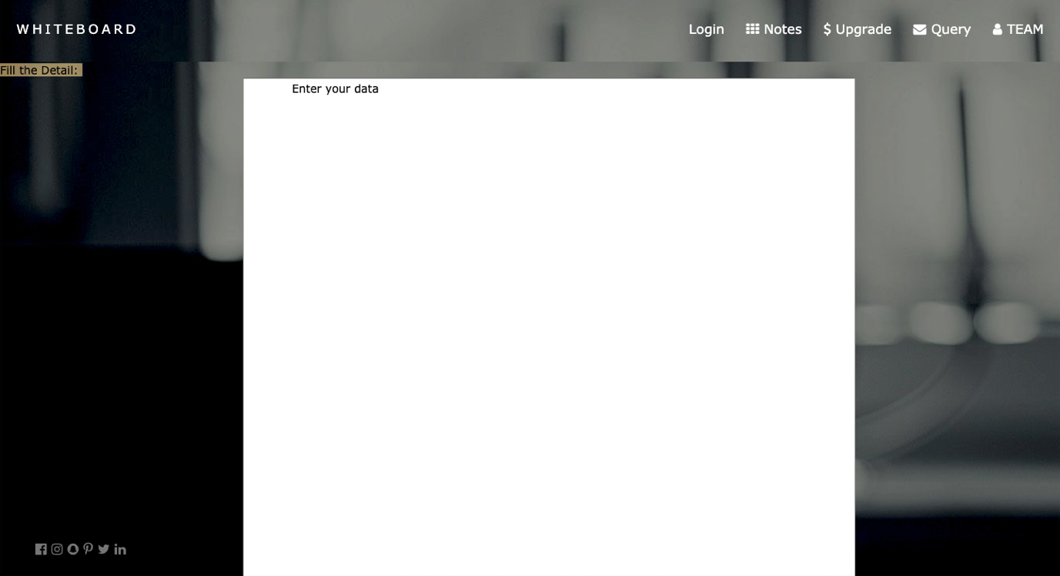

## Upgrade

Upgrade page is used to show the integration of PayPal. All the students can get access to more services and better connectivity with the experts in the particular field of subject. Upgrade versions are divided into three parts with different benefits. In which basic version gives the 5gb data limit per month to store the files and download the files, 100 free emails for the users through which they can directly ask questions and doubts to the concerned experts and 10 feedbacks from the experts on particular topics with endless support.

Pro version will provide access to 10gb of data limit per month and with 150 emails and 20 feedbacks from the subject experts with endless support.

Furthermore, the premium version will provide access to 20gb of data limit per month and with 500 emails and endless feedbacks from the subject experts with endless support.

To get these accesses and benefits, users can pay as per their requirement by using the PayPal method of payment.

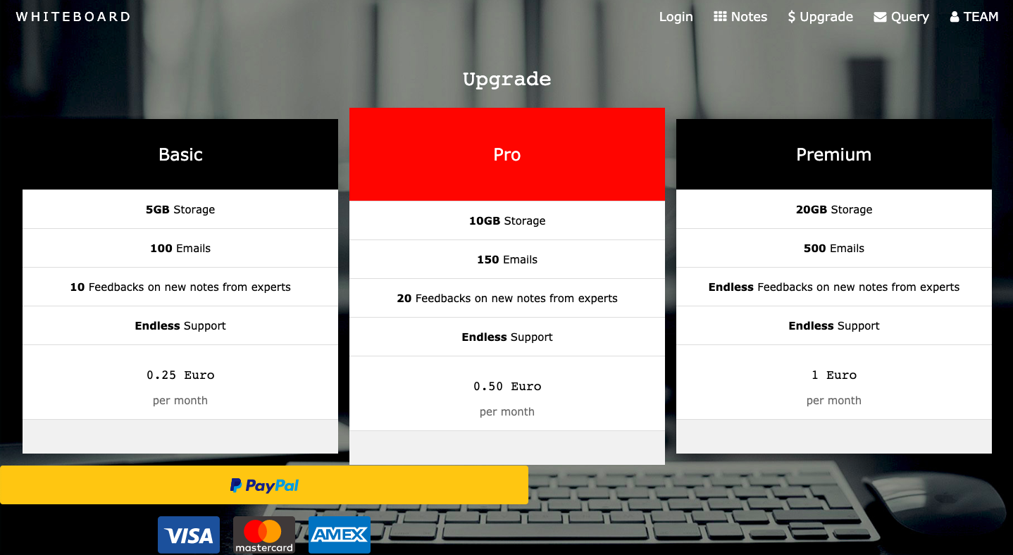

## Query

In the form of query, users can email us if they are facing any issue regarding the overall whiteboard page. The page includes Gmail integration, in which if the user types the information given in the form and clicks on the send button, then [whiteboard.dbsprojects@gmail.com](mailto:whiteboard.dbsprojects@gmail.com) will receive the email mentioned by the user in the query form. There is easy access to the contact details has been used for the convenience of the users.

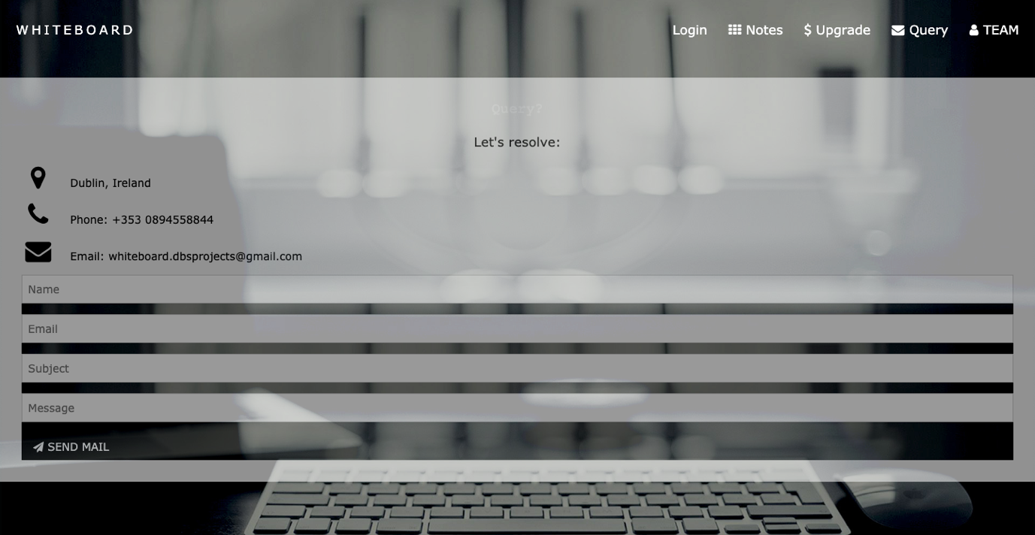

## Team

The team of the development and management of this project includes the listed people in the screenshot below. This page of the web app also includes information regarding career opportunities. This information aimed to provide a LinkedIn connection within the page so that people can have access to the information of the team members.

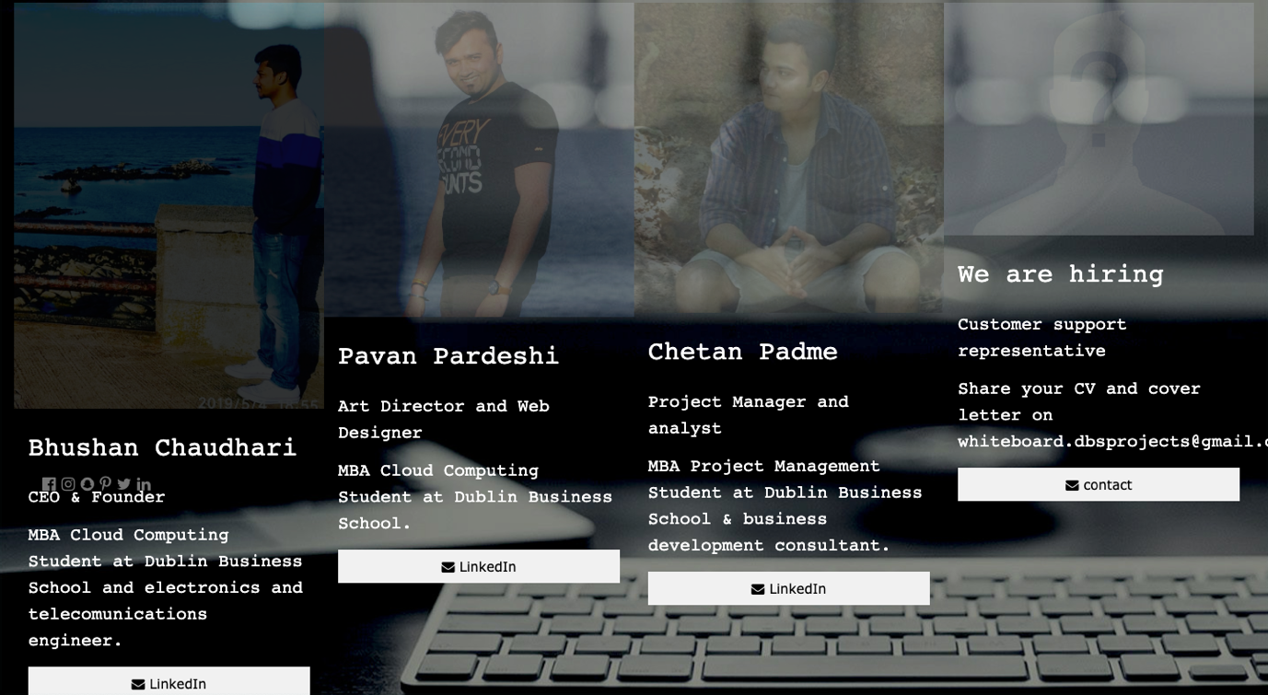

# 

# Applications and software used

## Microsoft azure

The basic use of Microsoft azure was to create a virtual machine and to manage the interface during the whole project work.

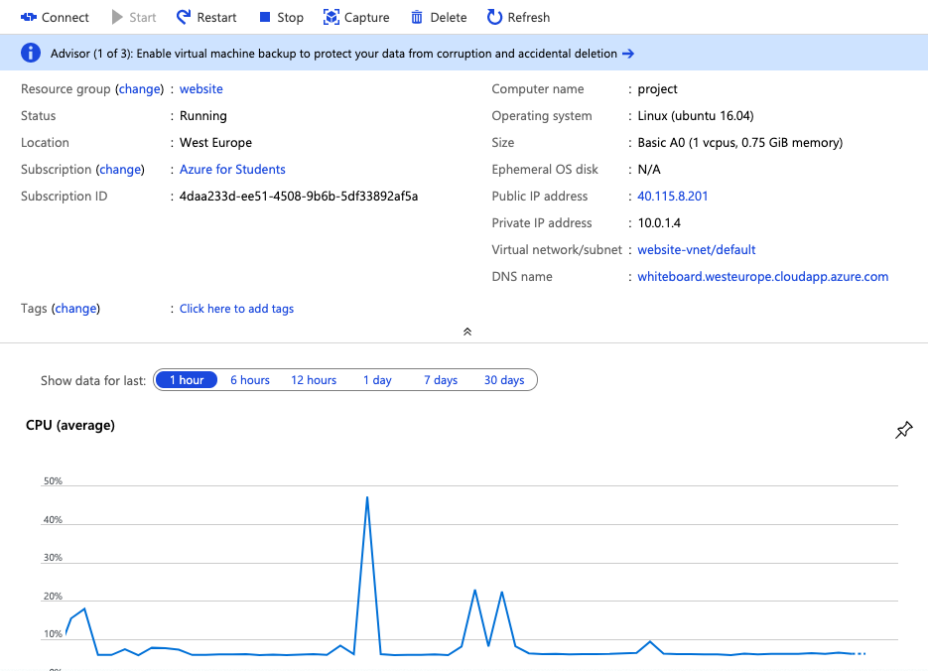

## GitHub

We used GitHub as a primary source to upload data as well as to share amongst group partner and professor. This app also provides a better platform for the developers to manage the information in a very simple manner. As this software monitors every commit and shares every file with the other users and teachers, we used it for better convenience. Our GitHub repository is shared and in which all the commits have been recorded. In the records of commits, we used bhushan08294/website ID for most of the time because another contributor of this repository whose username is Pavan100893 is using windows machine which was not responding to a few of the services. As a result, both of the contributors were using the same machine and single GitHub account which is bhushan08294. In this report and project, both of us were contributed equally.

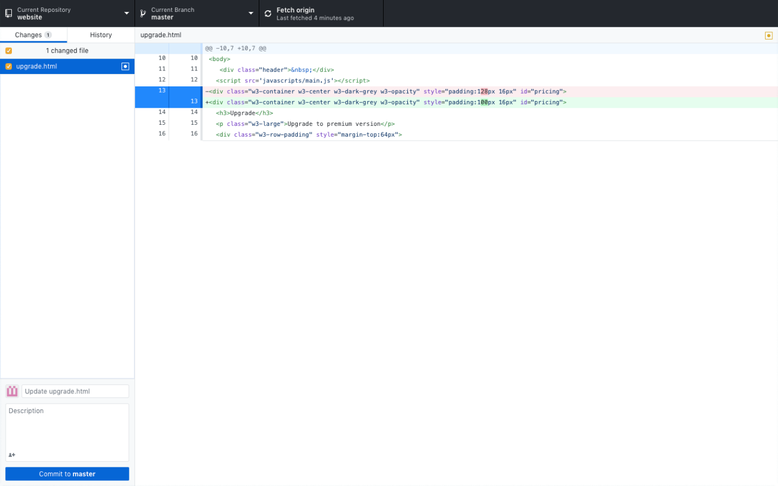

## Sublime text2/Notepad++

To write a code we used sublime text2 in which we wrote code. For windows machine we used Notepad++.

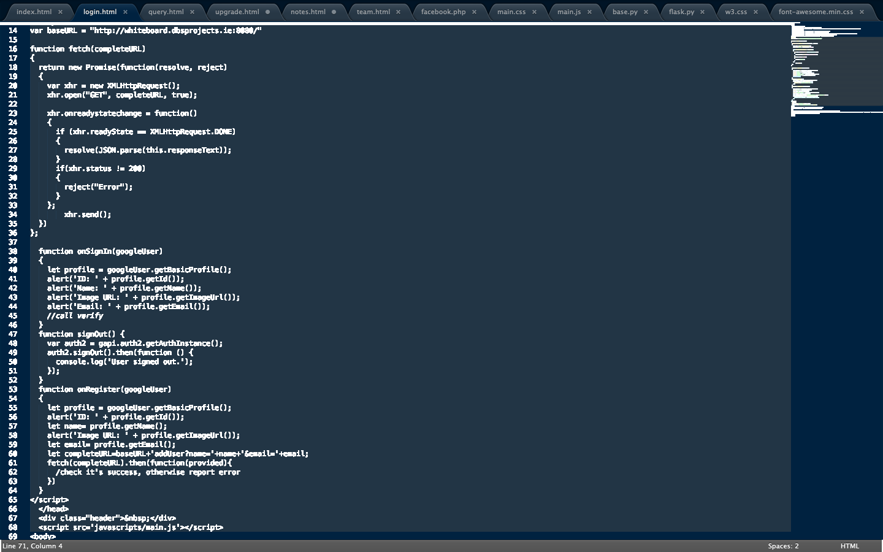

# Database & Languages

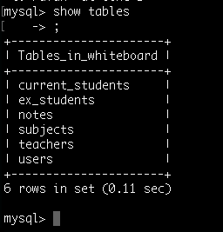We prepared this database based on MySQL. Using this we prepared a database and the database is consists of six tables such as current-students, ex-students, notes, subjects, teachers, users. These tables are used to fetch the database from the front end of the website. The website is based on three roles which are current students who are studying and expecting to upload notes and get their notes verified by the experts. Current students can also look into the notes uploaded by the ex-students. On the other hand, teachers can have a look at the uploaded notes, and they can also upload their files for the reference of students who all are registered with the whiteboard.

In the database, we added data to look after the SQL connections and as per the samples mentioned here are few of the database details are mentioned below.

For making this project live, we used languages such as python, JavaScript, HTML, and CSS. The HTML code which we have written, we used the Apache server to build a firewall to secure the website.

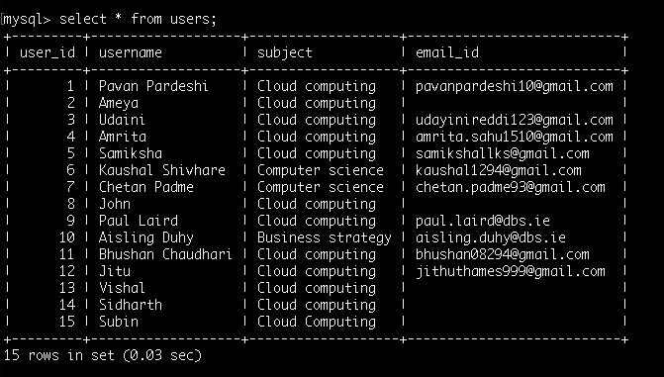

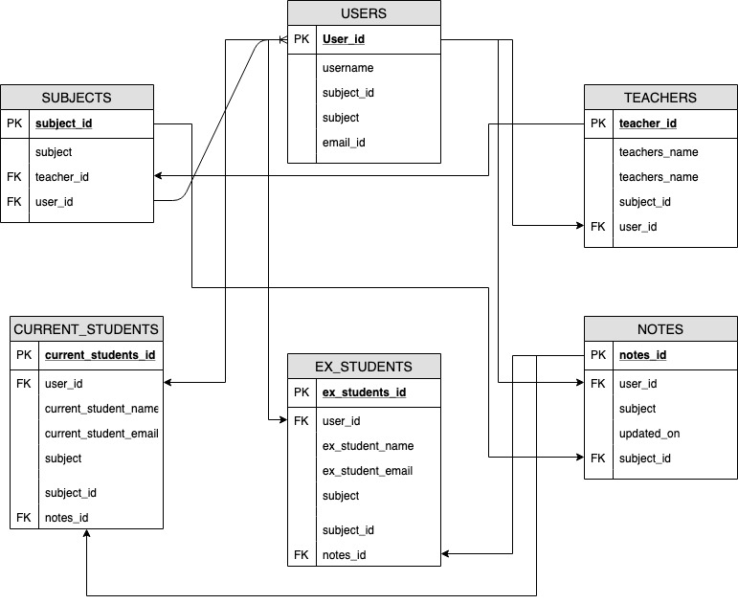Using the given ER diagram we created the database as explained above.

# 

# Conclusion

In conclusion, we introduced the whiteboard notes taking the application. This web application is for the students to explore their knowledge and to verify their notes from experts. However, the roles mentioned in the website are teachers, ex-students, current students. Our integrations for this website are:

* PayPal for making payment to use upgraded services
* Google sign in for the authentication of the user when trying to login.
* Gmail integration to receive queries from the users to the whiteboard team.
* LinkedIn to look at the profile information of the team members.

At the end, we are failed to connect the database with the website by using python3 code. Due to which we are unable to retrieve the data from front end to the database.